PROBLEM 1: Rainbow color map

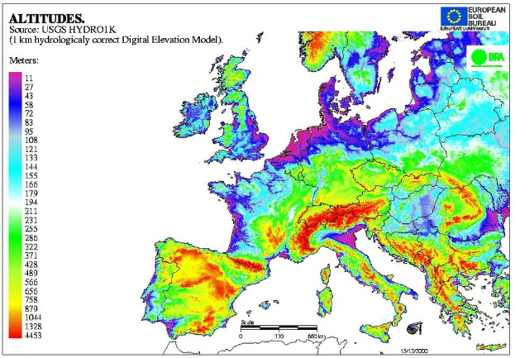

<https://www.safaribooksonline.com/library/view/designing-data-visualizations/9781449314774/httpatomoreillycomsourceoreillyimages898022.png.jpg>

inteded objective: show the altitude of different countries in Europe.   
Audience: people how want to look up altitudes around europ.

Yes, in a way. At first site there is no easy to detirmen which color is low and which is high alltitude. Especially all the alltitudes in between. If you knew that this color pattern was of the light spectrum you might understand it without a legend.

No. I can be done with 2 colors or maybe even 1.

PROBLEM 2: Patterns and colors in 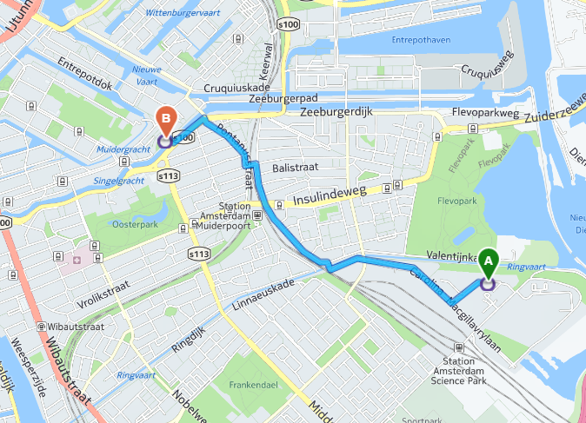yahoo: https://search.yahoo.com/search;_ylt=AuArvj7BRHj1cUAiVy3J3RNDVssF;_ylu=X3oDMTByaTN1NDdhBHNlYwNVSCAzIERlc2t0b3AgU2VhcmNoIDEwMA--;_ylg=X3oDMTBucmRhZWhqBGxhbmcDZW4tVVMEcHQDcG1oBHRlc3QD;_ylv=3?p=map&fr=ush-everything_uh3_02#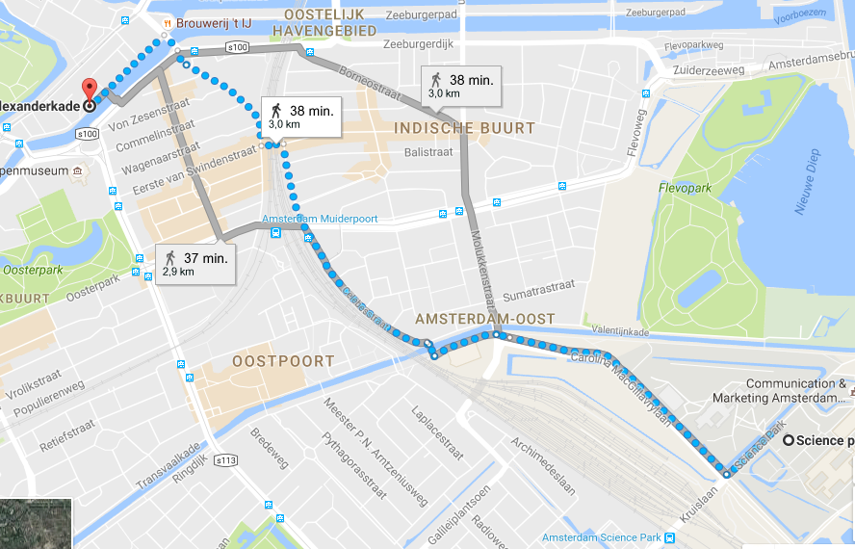

Google: https://www.google.nl/maps/dir/Science+park,+Science+Park,+Amsterdam/Alexanderkade,+Amsterdam/@52.3603622,4.9247426,3187m/data=!3m1!1e3!4m14!4m13!1m5!1m1!1s0x47c60944ecd0187d:0xbae0bc22b93e4985!2m2!1d4.9540186!2d52.3553427!1m5!1m1!1s0x47c6097539a78e85:0x94ce4c253987c895!2m2!1d4.9228371!2d52.3644252!3e2

Both of them are not very good in visual search for specific buildings. Google shows different districts. Both visualize the same route. Google shows alternitive routes, yahoo doenst. Google makes a distinction between more different types of transportation than yahoo.

Google has the better overall visualization as it provides more information such as alternative routes and city districts. Yahoo does provide more contrast and a more vivid visualization but if you’re only interested in your route from A to B, a contrasting highway might be distracting.